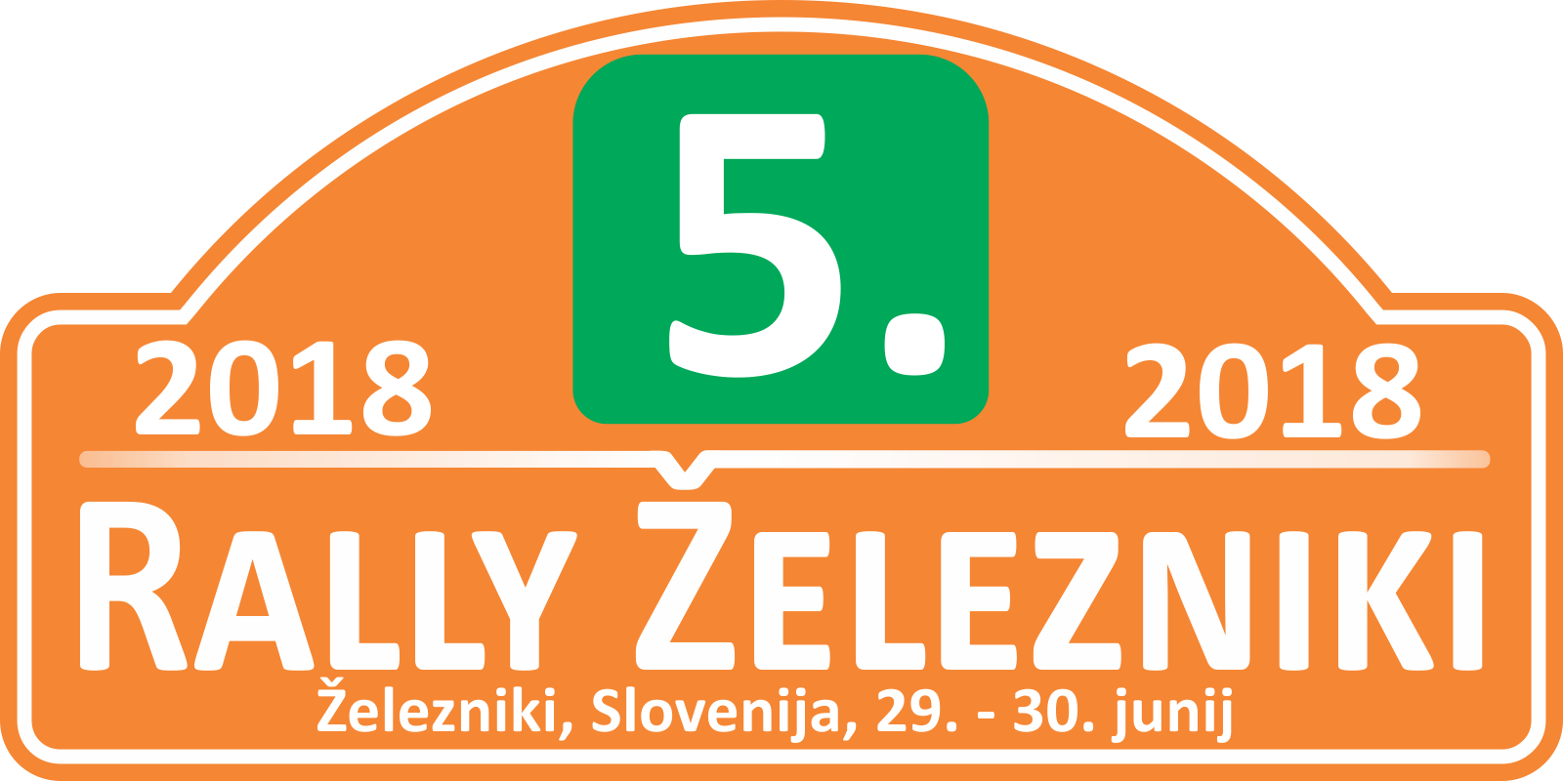

**5. RALLY ŽELEZNIKI**

Železniki, 29.6 in 30.6.2018

http://rally.omikronplus.si

**IZJAVA/AGREEMENT**

**MEDIJ / MEDIA:** ___________________________________________

**IME IN PRIIMEK: / NAME AND SURNAME:**

_________________________________________

**VAŠA VLOGA / YOUR ROLE AT EVENT:** novinar fotograf TV

*S podpisom potrjujem, da na 5. Rally Železniki ne bom uporabljal letečih pripomočkov za snemanje (mini helikopterji, droni itd)*

*I am fully aware that I at 5th Rally Železniki will not use any of flying object (like dron’s helicopter’s etc…)*

KRAJ, DATUM IN PODPIS / PLACE, DATE AND SIGNATURE:

____________________________________